Cafeteria Composting | September 2022- current | This school year, we joined the other pilot schools in BCPS with composting! Our compost is picked up twice a week and brought to a facility. Our students have been working tirelessly to encourage all students how to compost. | See below for data, pictures of students composting, and a school-wide announcement.  2,690pounds to date

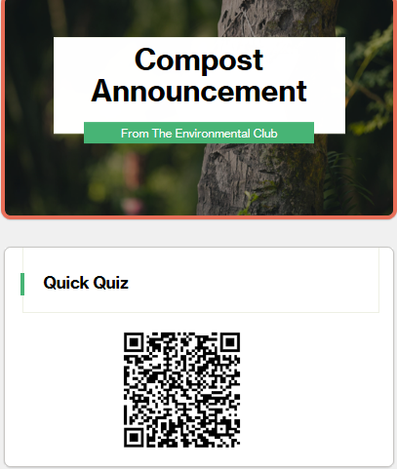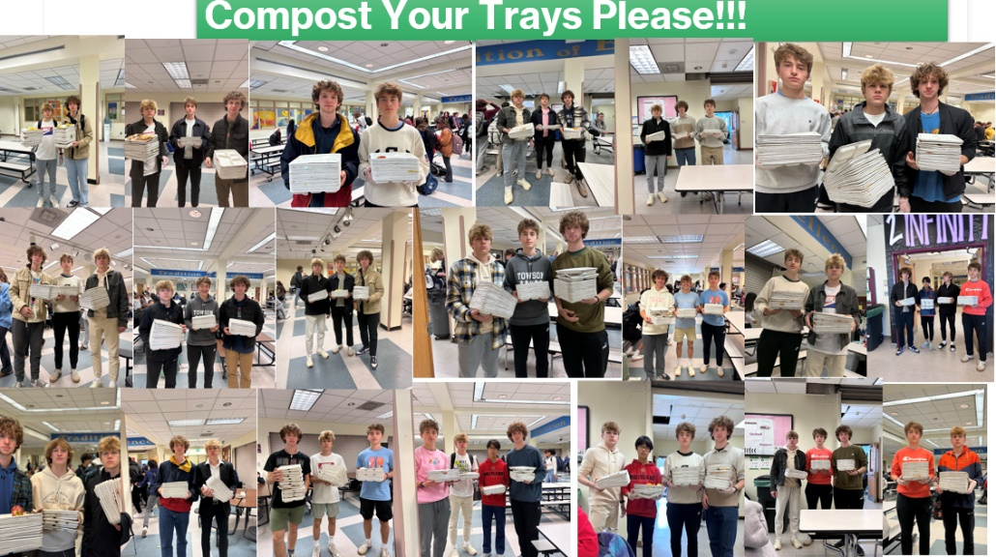
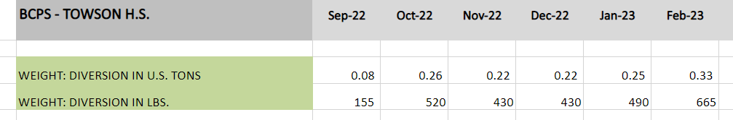
COMPOSTING EVIDENCE
